The university of Azad Jammu and Kashmir ,
Muzaffarabad

Name | Nida Mughal
Roll no | 2024-SE-41
Course Title | Database System
Lab | 5
Submitted to | Dr. Asma javeid

Department of Software Engineering
Lab#5

Objective and overview:
In this lab, we configured a router using Cisco Packet Tracer CLI. We accessed different command modes and applied basic configuration commands to set passwords, secure the device, view configurations, and save settings.

- Enable:

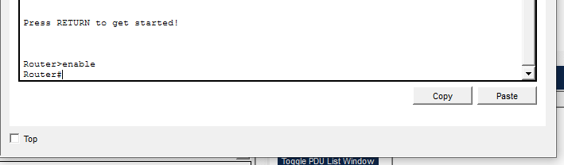
This command is used to enter privileged EXEC mode. It allows access to advanced configuration and monitoring commands.

- configure terminal:

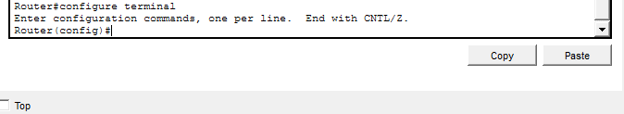

This command enters global configuration mode. It is used to make changes to the router settings.

- enable password cisco:

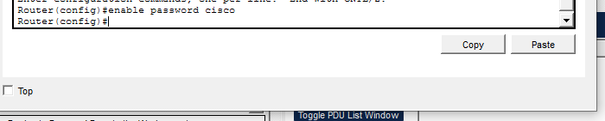
This command sets a password for privileged mode access. It provides basic security for the router.

- service password-encryption:

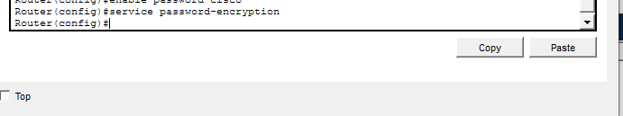
This command encrypts all plain text passwords in the configuration. It helps protect passwords from being viewed easily.

- enable secret class:

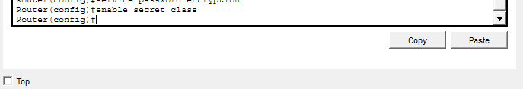
This command sets a secure encrypted password for privileged mode. It is more secure than the enable password.

- End:
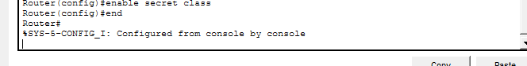
This command is used to exit from configuration mode and return directly to privileged EXEC mode.

- Do show running-config:

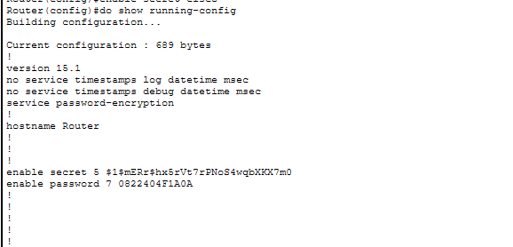
This command displays the current active configuration of the router. It shows all settings stored in RAM.

- do show startup-config:
This command displays the saved configuration in NVRAM. It shows settings that load when the router restarts.

- copy running-config startup-config:

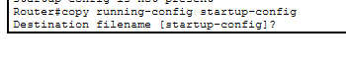
This command saves the current configuration to memory. It ensures the settings are not lost after reboot.

